[Your Name]

What have you learned? Provide evidence that you have met the course outcomes. In the syllabus it states that as a successful learner, you will be able to:
- Use functions, data structures, and other programming constructs efficiently to process and find meaning in data.
[Answer Here]
- Programmatically load data from various types of data sources, including files, databases, and remote services.
[Answer Here]

- Use data manipulation libraries to perform straightforward analysis, produce charts, and prepare data for machine learning algorithms.

[Answer Here]

- Use machine learning libraries to discover insights, make predictions, and interpret the success of these algorithms.

[Answer Here]
- Use industry-leading tools to collaborate and share your work.
[Answer Here]

The next data science course you plan on taking.
[Answer Here]

The final grade that you are requesting is based on the work you have submitted. (See the syllabus competencies for an example of a grade request paragraph.)
Example:
Evidence I met course outcomes: (Met requirements to pass)
- Use functions, data structures, and other programming constructs efficiently to process and find meaning in data.

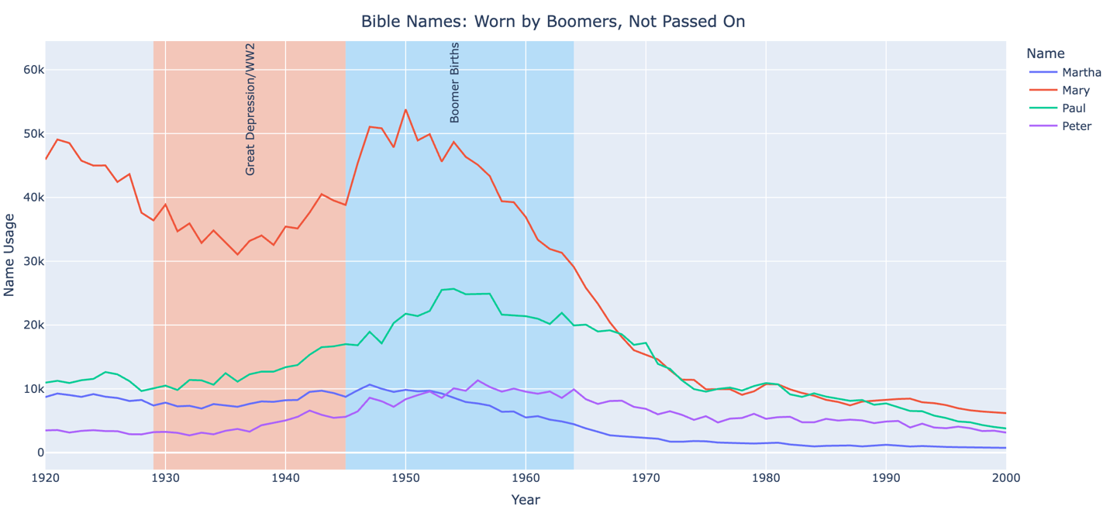
When looking through the names data, I was surprised that the Bible names used to be so much more common than they are now.

- Programmatically load data from various types of data sources, including files, databases, and remote services.
I was able to do a lot of the basics using “pd.read_csv()” to read data from my machine and from the url’s provided in class. I also read in JSON files, but most importantly was the work we did using SQLITE. This code is a good example:
sqlite_file = 'lahmansbaseballdb.sqlite'
con = sqlite3.connect(sqlite_file)
q = 'SELECT * FROM batting LIMIT 100'
batting5 = pd.read_sql_query(q,con)

- Use data manipulation libraries to perform straightforward analysis, produce charts, and prepare data for machine learning algorithms.

I have learned how to deal with missing data, especially using the replace() function and np.nan. But I haven’t finished project 3 yet, which is where I believe I will get a lot of practice with this sort of thing.

- Use machine learning libraries to discover insights, make predictions, and interpret the success of these algorithms.

We haven’t covered machine learning yet

- Use industry-leading tools to collaborate and share your work.
I liked using Slack to communicate with the class. Brother Lewis was not great at it. He always hits “enter” instead of “shift+enter” for a new line. He’s a math dude though, so I give him a pass.
Tasks: completed 100% so far, A
Project Stretches: None so far, so probably a B or C
DS Community: 2 so far, but I have an informational interview scheduled for next week which will get me to 3. Plus I plan to keep attending Data Science Society. So I am definitely on track for an A
Attendance: I missed a week of class due to illness, but I think I have fully recovered and don’t anticipate missing more classes.
Coding challenge: Don’t know yet, but I am learning a lot and anticipate doing well.
I am on track to get an A. I feel that doing the reading before class, and even trying the homework for 15 minutes before class really helps me key in on what I need to know. The stretches are difficult, but I rely on the DS250 Chatbot to help me, and it saves me a lot of time. (I don’t use the Chatbot during the tasks because you asked us not to ).

